Linux Fundamentals

================================================================

Submitted to Vikul_Sir

Submitted by Nalathati Rahul

Submission Date –03/Feb/2026

================================================================

L6 - Write a Linux Shell Script to Install Git, JDK, Maven in EC2 Ubuntu Instance.

Step:1 Go to AWS console and login with credentials

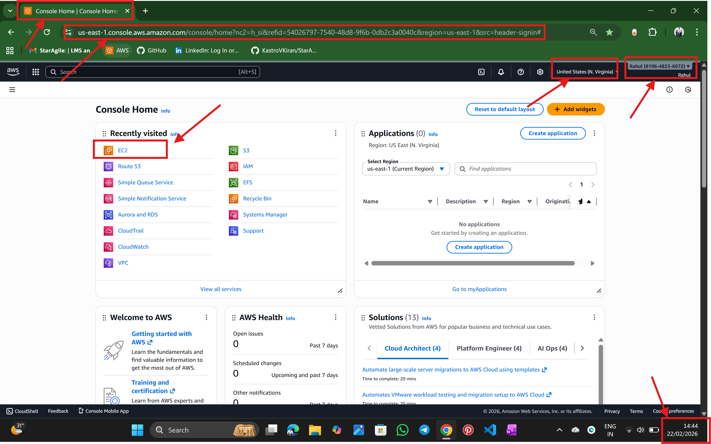

Step:2 Go to EC2 service

🡪select the name of the server

🡪select the AMI (Ubuntu)

🡪select the instance type

🡪select the key pair

🡪select the security group

And create instance by launch instance

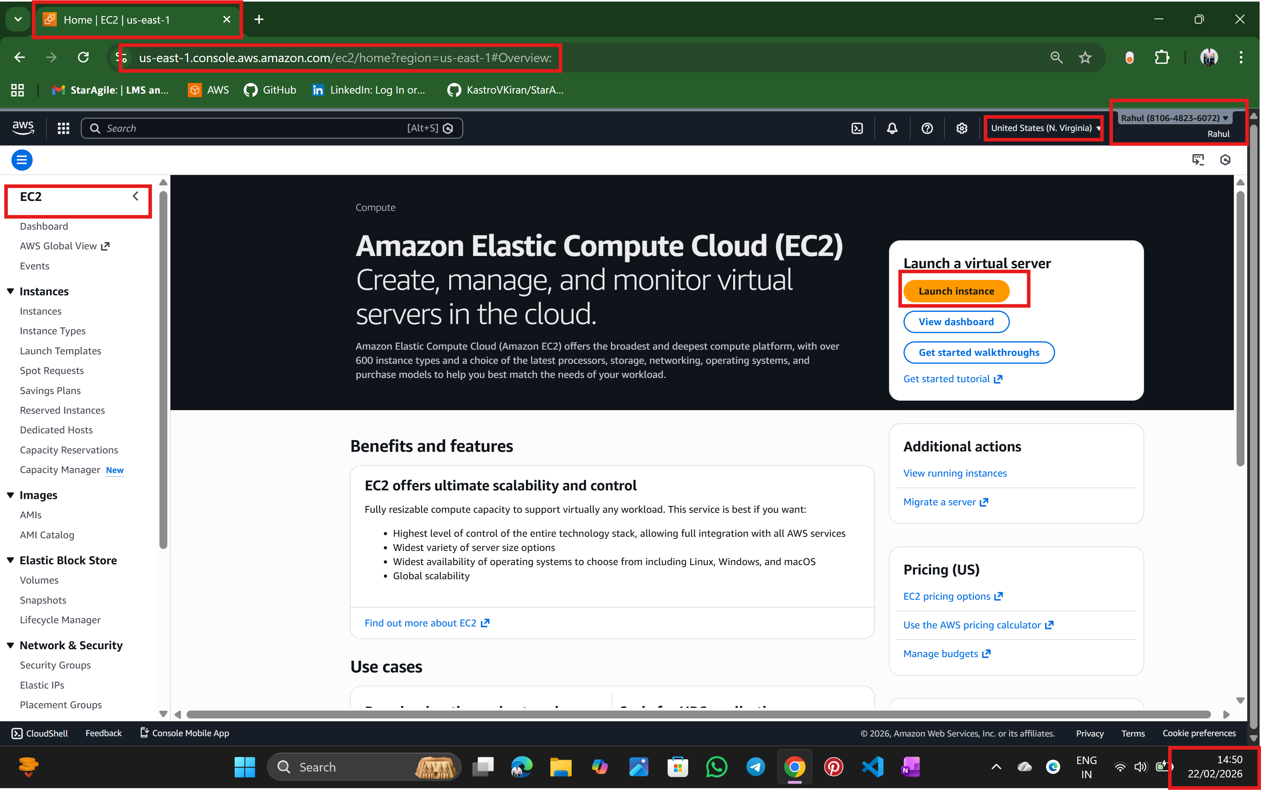

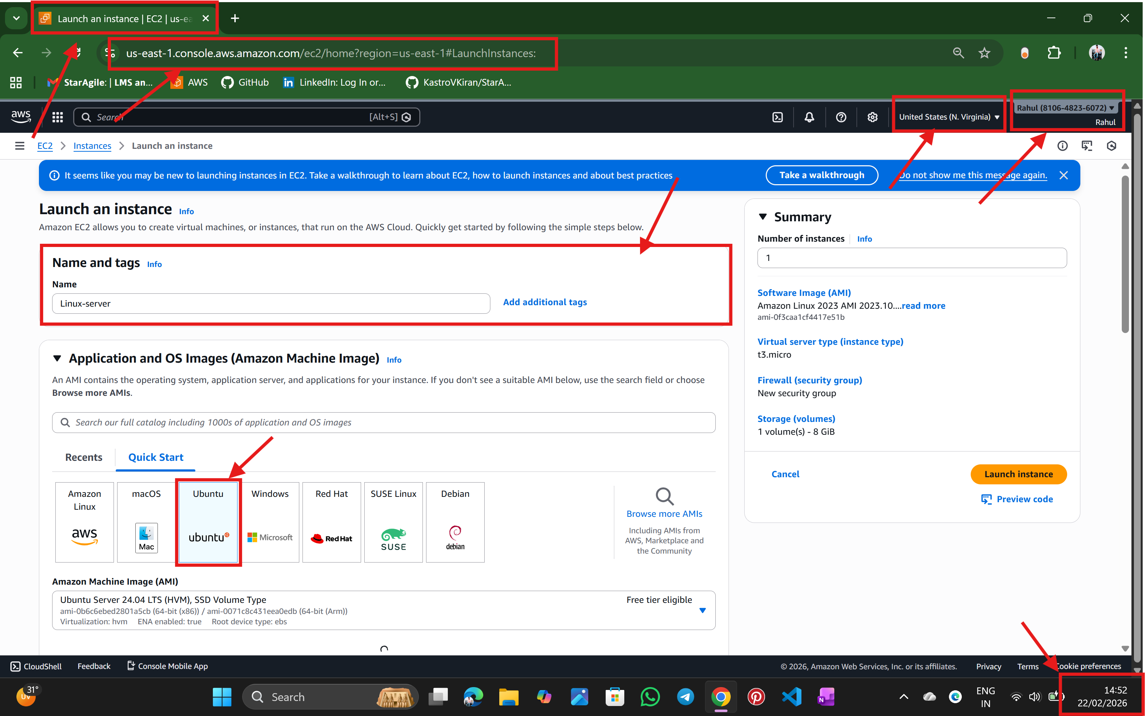

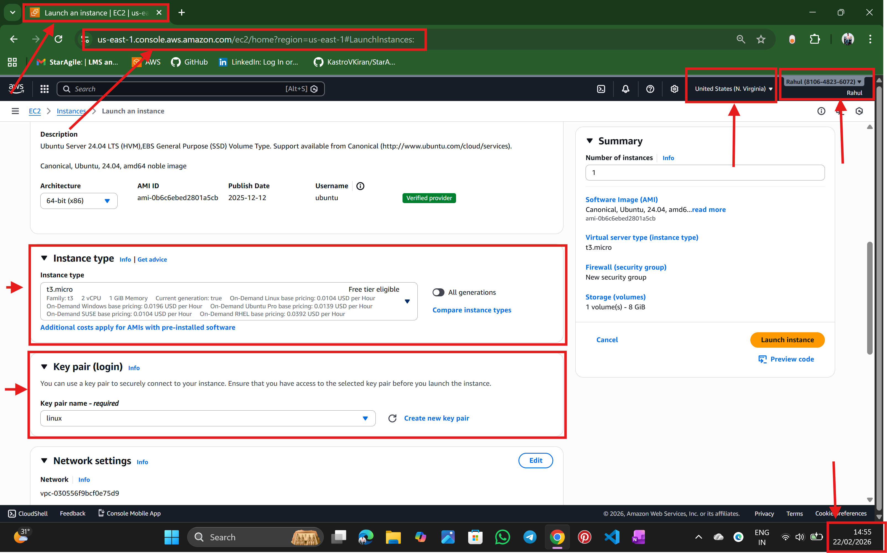

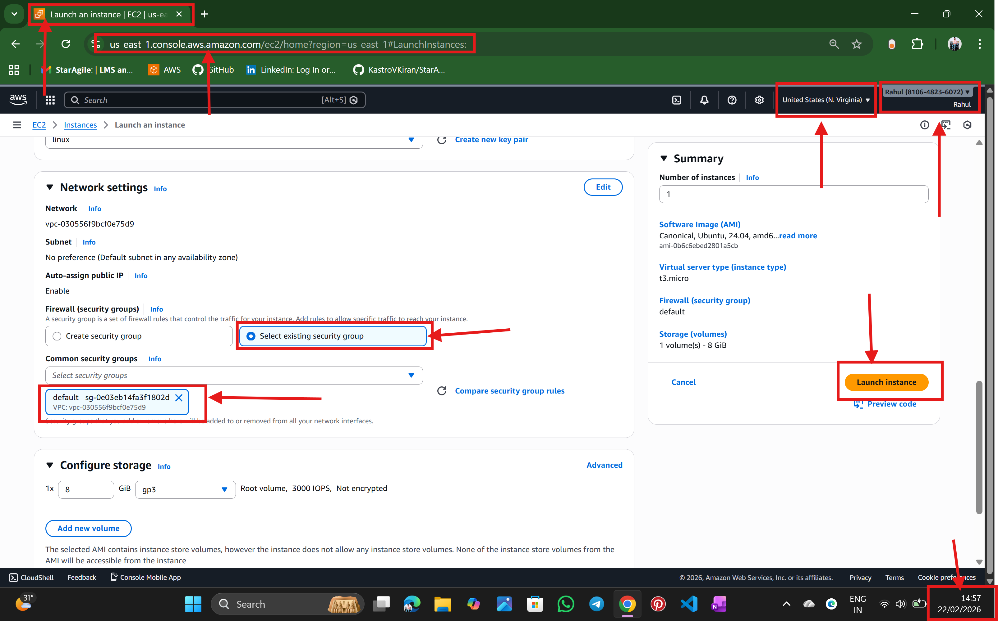

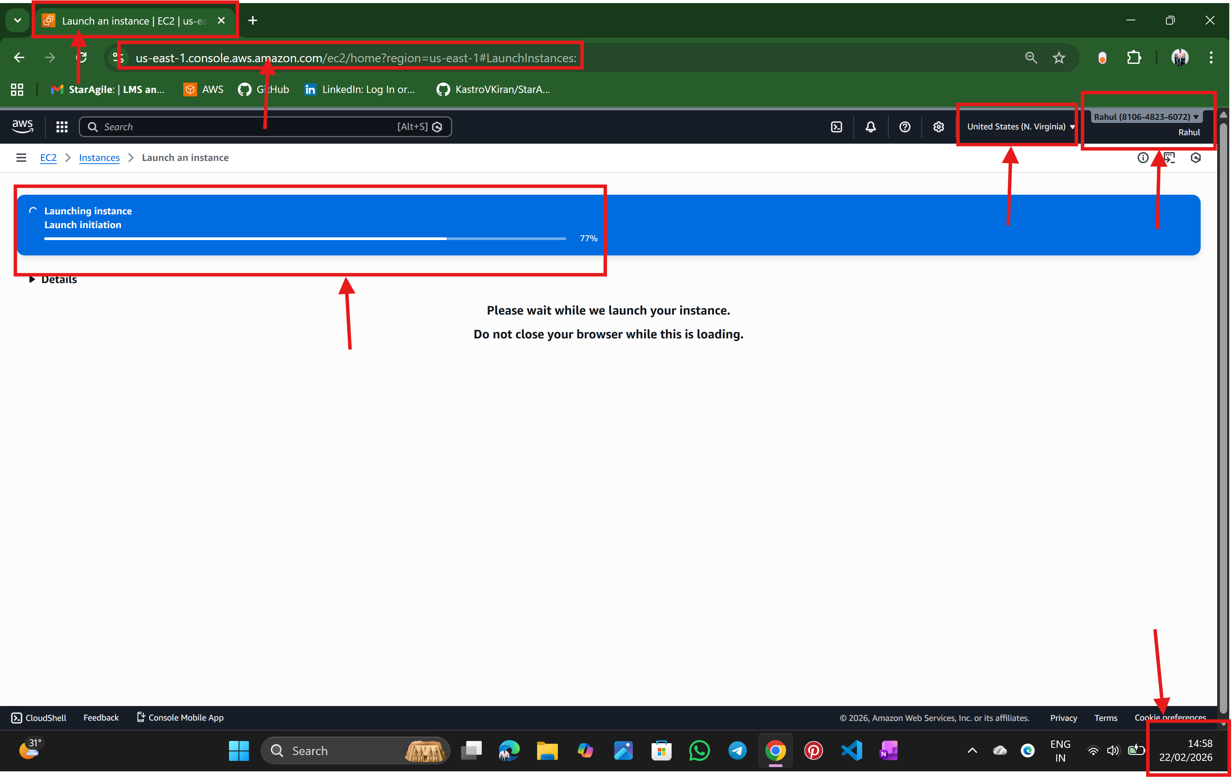

Step:3 now connect instance to ubuntu terminal

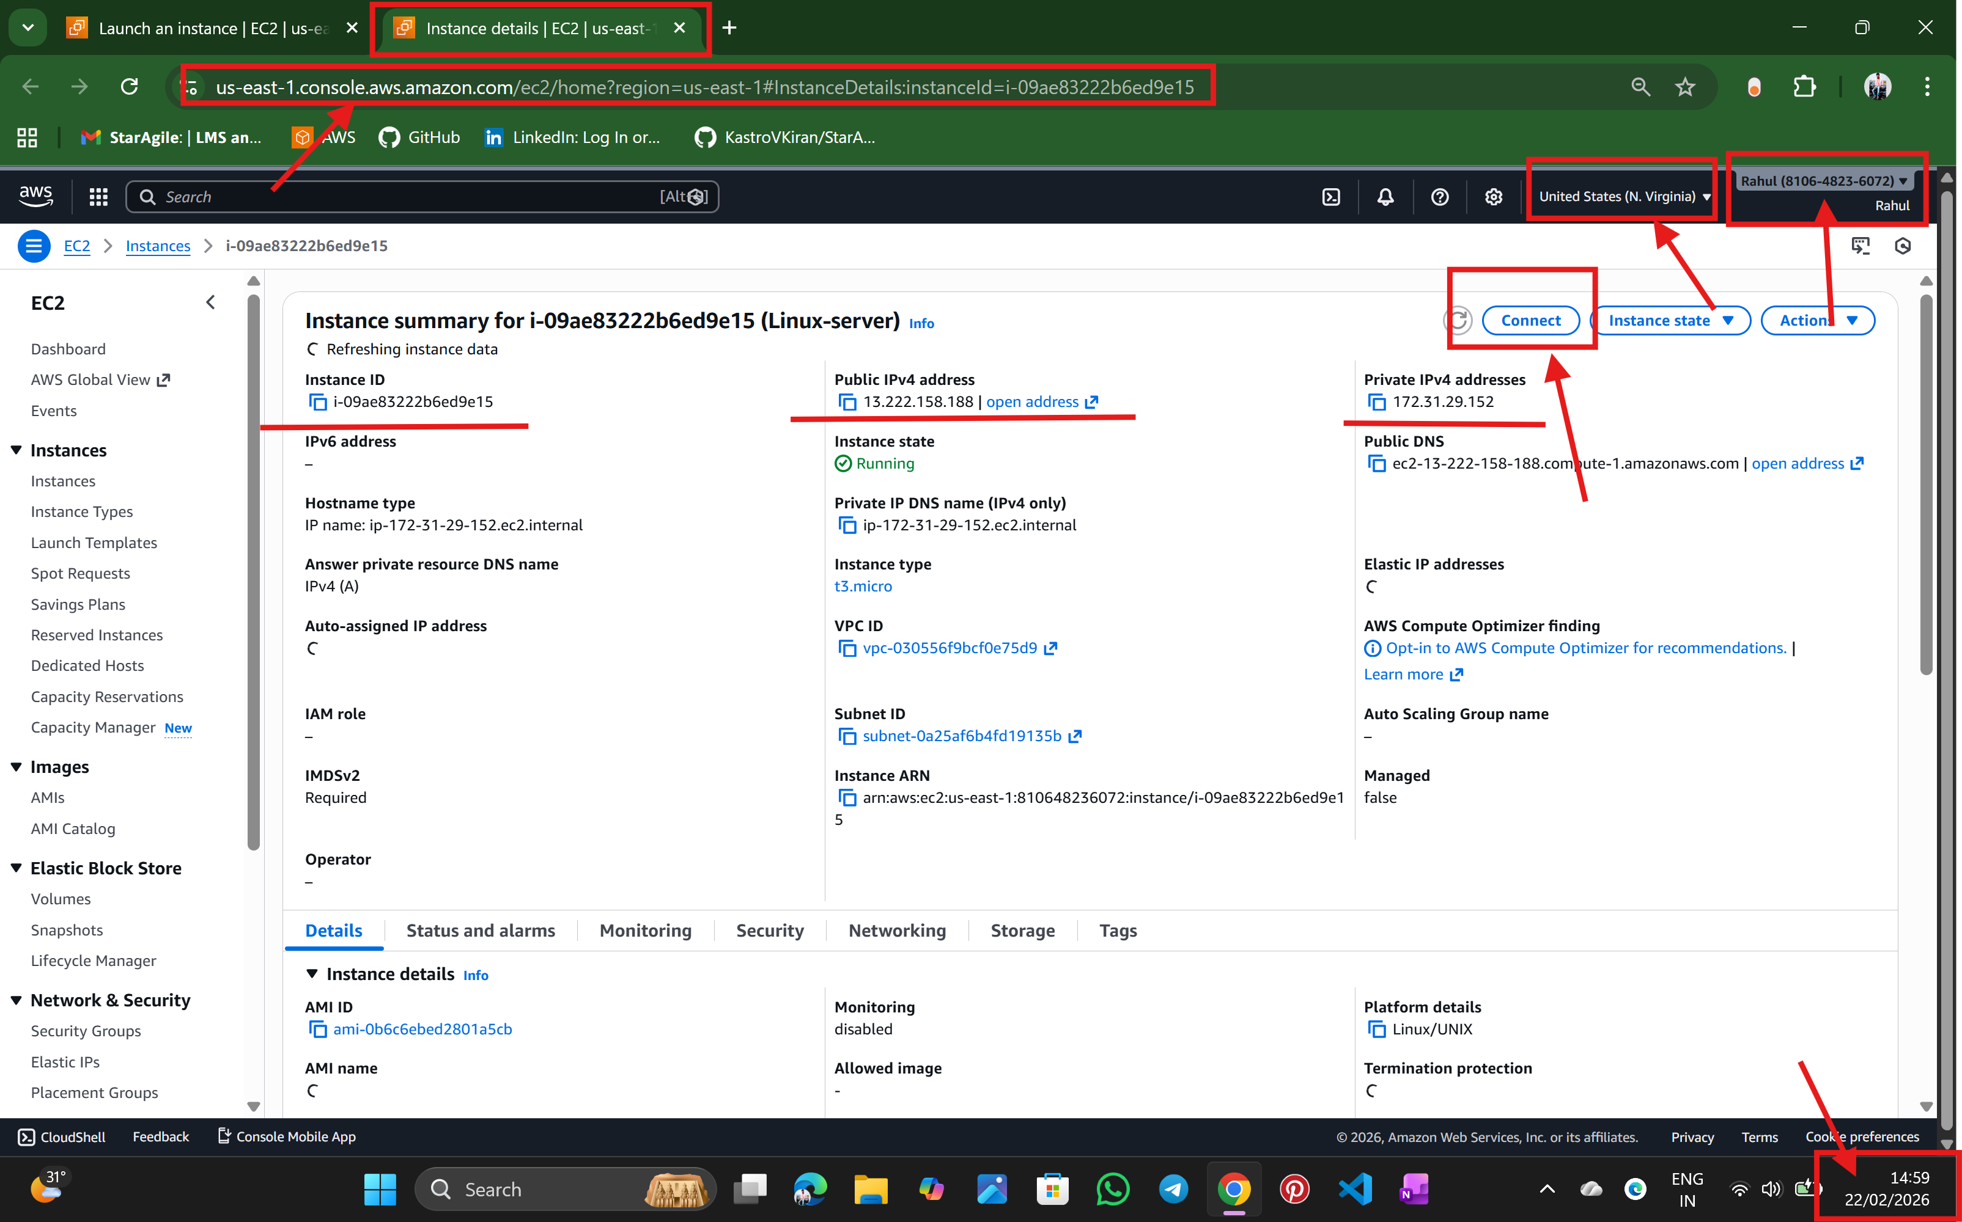

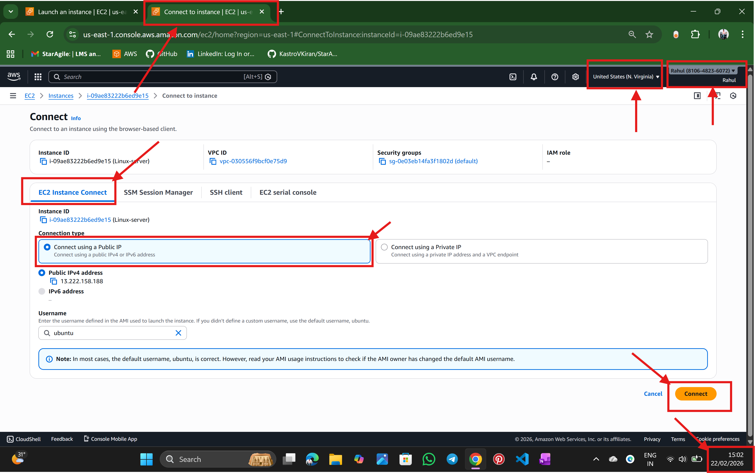

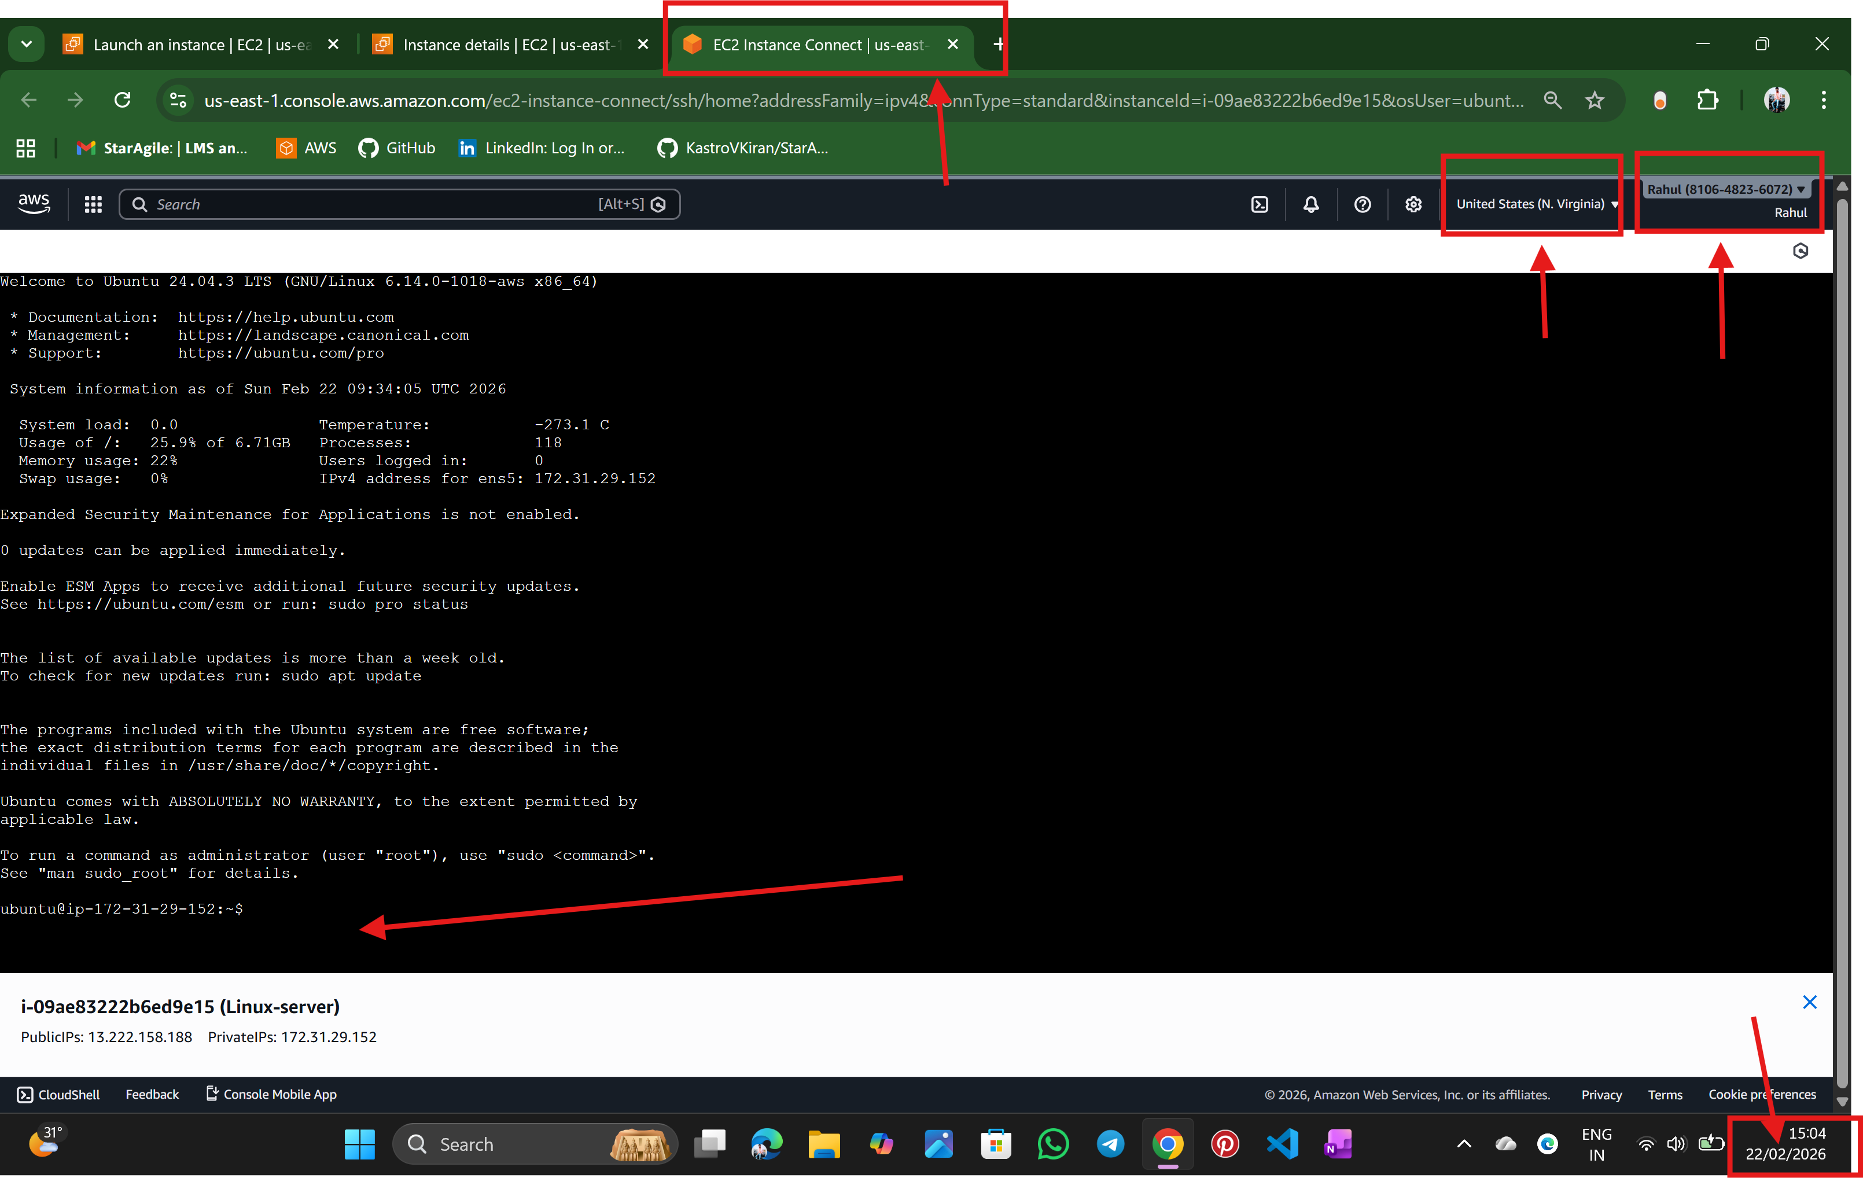

Step: 4 Now the Terminal is open

🡪Make a directory – using mkdir command

🡪create a file – using touch command

🡪write a shell scripting to install tools in the given question

🡪Using vim command write script in it

🡪change the permission if the file does not have execute permission –chmod

🡪execute the file -- ./<file name .sh> or sh <file name.sh>

Shell code

#!/bin/bash

echo "Updating packages..."

sudo apt update -y

echo "Installing Git..."

sudo apt install git -y

echo "Installing JDK..."

sudo apt install openjdk-17-jdk -y

echo "Installing Maven..."

sudo apt install maven -y

echo "Installation Completed!"

echo "Checking Versions..."

git --version

java -version

mvn -version

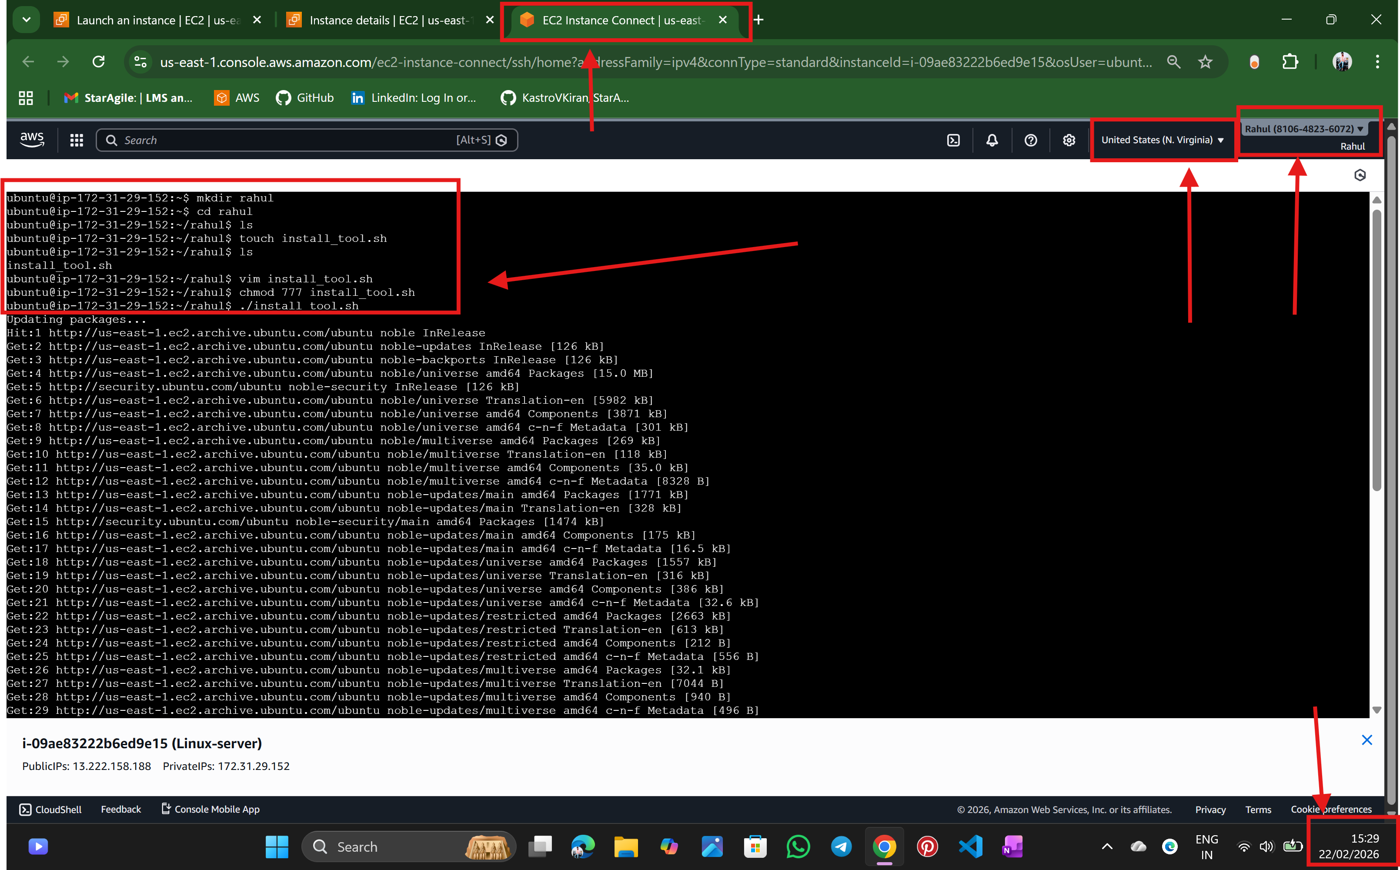

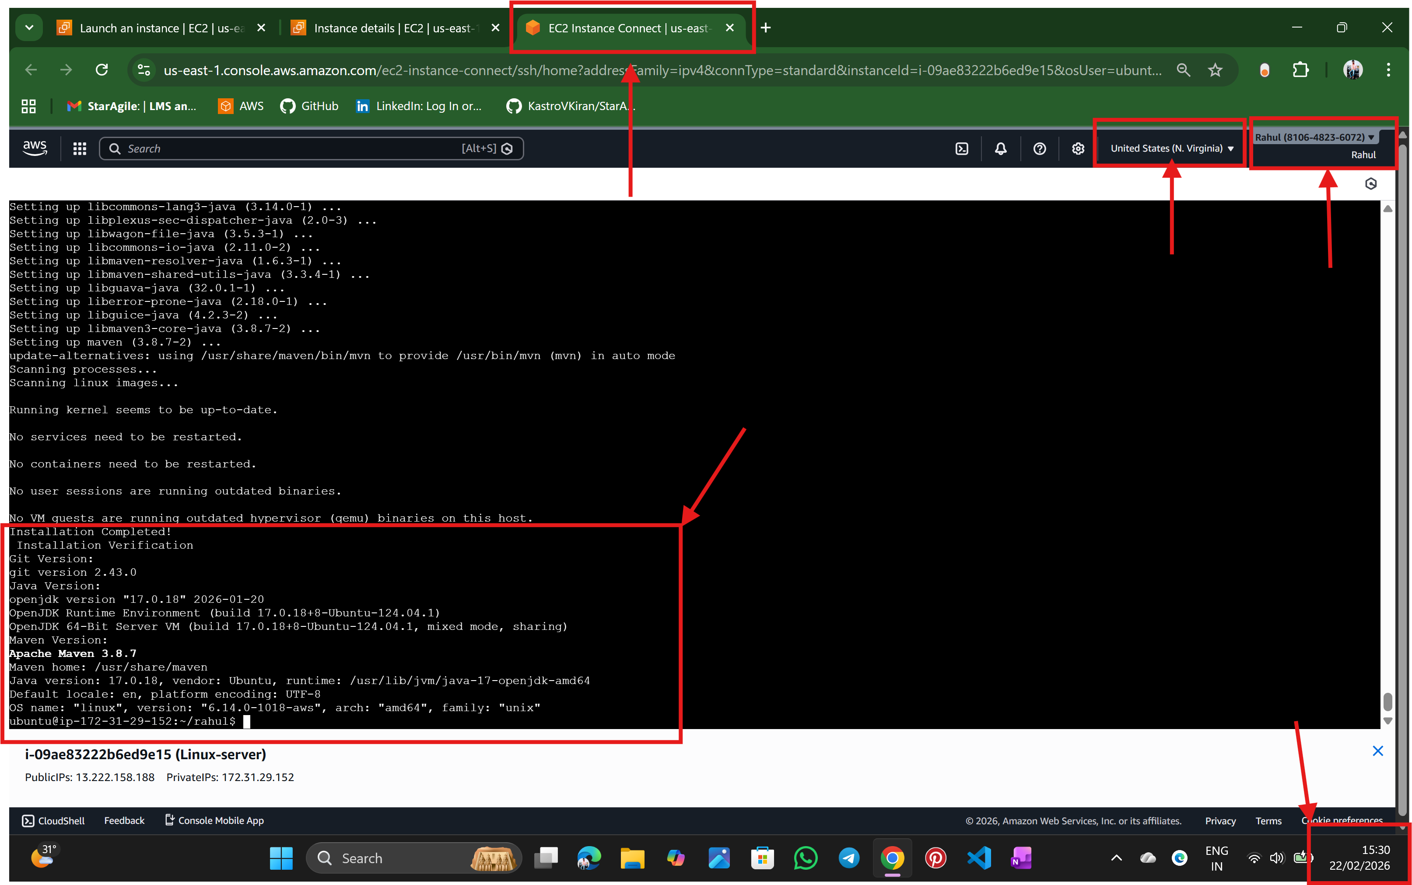

--------------------------------------------THE END -----------------------------------------------

🡪NALATHATI RAHUL